**McDonald's Menu Nutritional Analysis – Project**

**Name: Karan Sali**

**Github link :**

**https://github.com/KRASLHBD/McDonald-s-Menu-Nutritional-Analysis---Project**

**Instruction**

McDonald's is a global fast-food chain known for its diverse menu offerings. As a data analyst, your task is to analyze the nutritional content of the menu items available at McDonald's outlets. This analysis will provide valuable insights into the calorie count and nutrition facts of various menu items.

**Objectives:**

1. Extract meaningful information from the McDonald's menu nutritional dataset.
2. Perform exploratory data analysis to understand the nutritional distribution and trends.
3. Create visualizations to present the calorie count and nutrition facts of different menu items.
4. Identify healthy and less healthy menu options based on nutritional content.

**Tasks/Activities List:**

1. Data Collection: Download the McDonald's menu nutritional dataset from [this link.](https://kh3-ls-storage.s3.us-east-1.amazonaws.com/Data%20Analyst%20Project/Nutrical%20Dataset.csv)
2. Data Preprocessing:
   * Load and inspect the dataset.
   * Handle missing values and data cleaning if necessary.

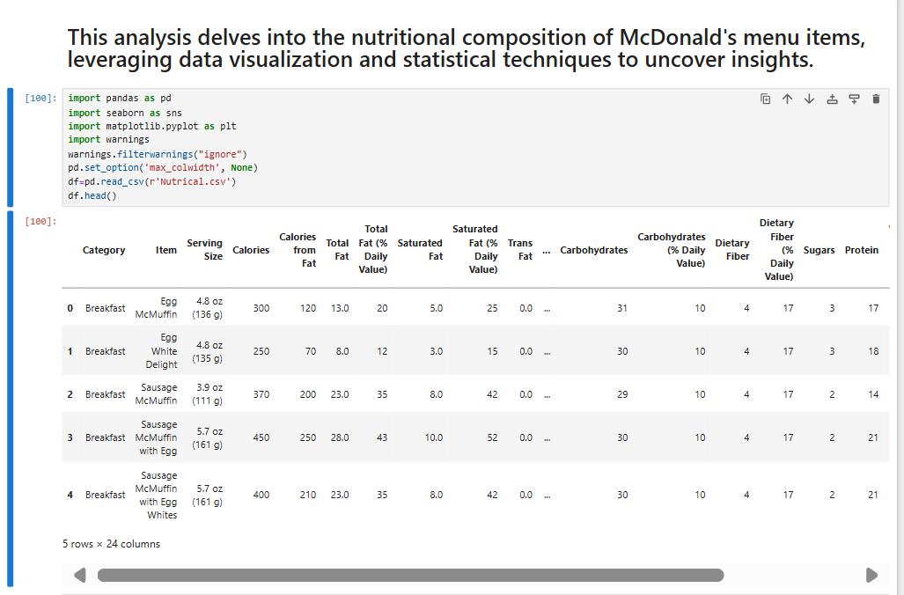

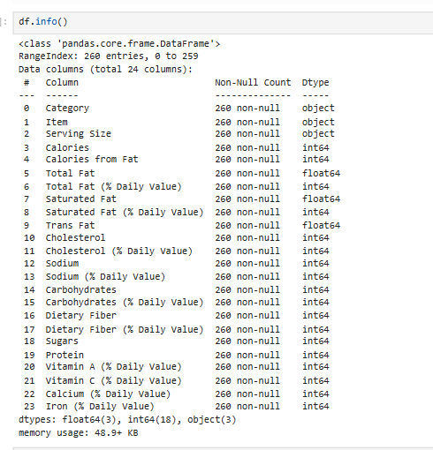

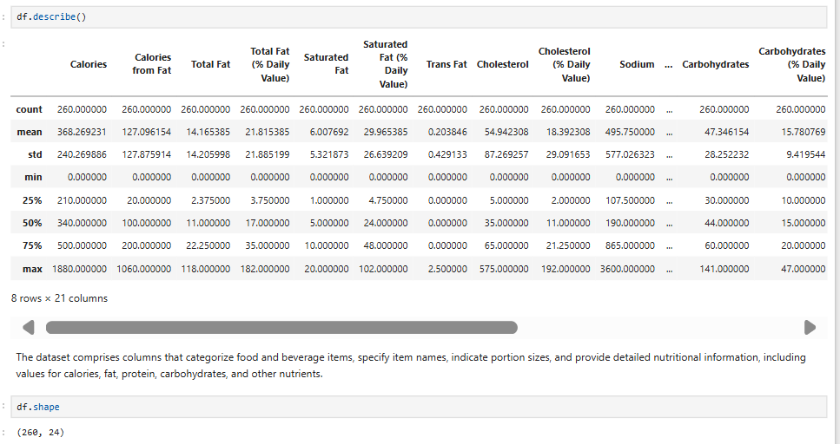

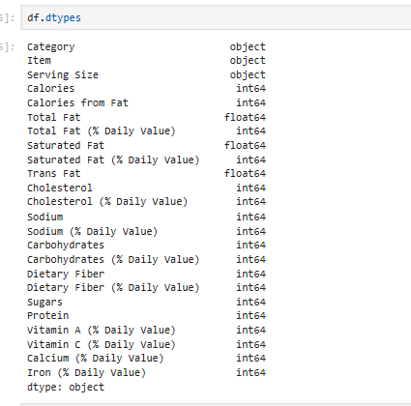

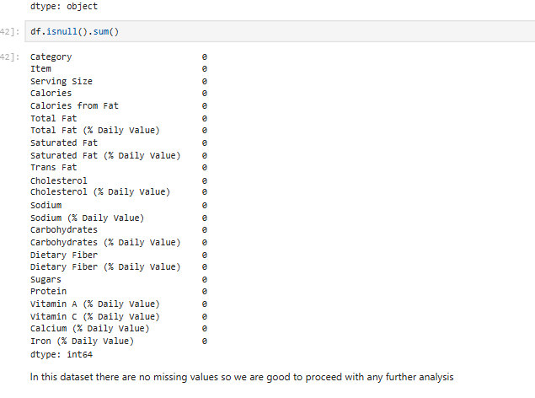

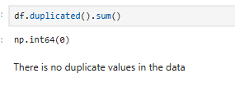

1. Exploratory Data Analysis (EDA):
   * Analyze the distribution of calorie counts across menu items.
   * Explore the nutritional content (e.g., fat, protein, carbohydrates) of different items.
   * Identify trends and patterns in the dataset.
2. Data Visualization:
   * Create bar charts, histograms, and box plots to visualize calorie distribution and nutritional content.
   * Compare nutritional characteristics of different food categories (e.g., burgers, salads, desserts).
3. Nutrition-Based Insights:
   * Identify menu items with the highest and lowest calorie counts.
   * Determine the average nutritional content of popular menu categories.
4. Documentation and Reporting:
   * Summarize the findings and insights from the analysis.
   * Explain how the nutritional analysis could benefit McDonald's customers and the organization.

